Indian Tribe
and
Resource Agency
Review and 1st Round

Consultation Package

In Support of the
Licensing for the

Rock Creek Retrofit Power Project

Submitted for Review by

Davis Hydro, LLC

Currently FERC Project 11866-000
Preliminary Permit in the name of
Davis Hydro

Prepared by

Davis Hydro, LLC
Davis, California
530 753-0562
hydro@davis.com

Table of Contents
Table of Contents i
Introduction 1
Background of Davis Hydro, LLC 1
Relations with PG&E 1
Rock Creek Retrofit Power Project: Background 1
Detailed Maps: 2
Environmental Resources 2
Cultural Resources 3
Historical and Archaeological 3
Natural Resources 4
Scenic Beauty and Aesthetics 4
Animal Resources 4
Fish Habitat 5
Disease 5
Spillway Mortality 6
Turbine Mortality 6
Fish Populations: Summary 7
Recreation 7
Existing Physical Structure 8
Proposed General Engineering Design 8
Trash Booms 8
Trashrack and Inlet 9
Fish Diversion 9
Diversion Penstocks: 10
Turbines 10
Generators and Interconnection 11
Operation 11
Stream Flow and Water Regime 11
Mitigation: 12
Recommended Studies 13
Monitoring: 14
Other Concerns: 14
Other Hydropower Alternatives: 14
PURPA Benefits 15
Bibliography i
Documents i
Reference Dates and Project Discussion Documentation ii
Fish Passage References iii
Attachment I Drawings i
Attachment II - Flow and Use Data i
Attachment III - Regulatory and Project Information i
Site Information i
License Exhibit A Information iii
Suggested License Provisions: iv
Attachment IV Fish Passage Discussion i
Turbine Mortality i
Trash Rack Bar Spacing: ii
Attachment V Contact Sheet i
Active Distribution of all Materials i
Attachment VI Electronic Public Notification List i

Introduction
Davis Hydro, LLC intends to apply to the FERC for a license to retrofit the Rock Creek dam, and use the dam base instream release water for a small hydropower project with no changes in flows. This document is being circulated to all concerned stakeholders in this area, specifically to form a basis of consultation with the State and Federal agencies for their concerns. This filing describes the Rock Creek Retrofit Power Project (the Project), addresses environmental concerns, and invites comment and criticism of the plan.

Background of Davis Hydro, LLC
Davis Hydro, LLC (Davis Hydro) is organized to develop small hydro, and to perform related fisheries research. In cooperation with others we are operating the Sandy Hollow site in New York state, and are active at sites in California and Vermont. The engineering ideas and environmental concerns in this consultation package have been discussed informally with several agencies and interested parties over the past three years, but formal submittal has been delayed due adverse developments in the green power market. Currently, favorable contracts are becoming possible, and Davis Hydro hopes to develop this site in a manner most compatible with everyone’s environmental goals.

Relations with PG&E
Because the Project is located on, in, and immediately next to a Pacific Gas and Electric Co. (PG&E) owned dam, their cooperation was sought and has been generously provided. During the past three years we have met with administrative, management, and engineering staff from PG&E - primarily in 2001. PG&E staff have summarized their concerns and procedures both informally and in letters. Their concerns include:
- their responsibilities under their new FERC License to maintain environmental quality, specifically in-stream fish flow at all times;
- liability issues;
- non-interference with dam operations;
- dam integrity, and eventual equipment removal;
- ability to transmit the power out of the valley as there is another small hydropower site on the same 12 kV line.
Within the bounds of these and other engineering concerns, PG & E has given positive indications on the potential feasibility of this Project. They have provided guidelines on expected compensation for the site’s usufruct, requested a drawing account for expenses, and continuing to provide cooperation whenever asked. Specific significant communication is noted in the Bibliography, and copies of letters are available on request.

Rock Creek Retrofit Power Project: Background
The Rock Creek Diversion Dam on the North Fork of the Feather River has recently obtained a new License from FERC to divert most of the water out of the river to the Rock Creek Power House. Under the terms of this license the dam owner, PG&E, is required to release water according to the Rock Creek – Cresta Settlement Agreement (the Settlement) dated December 2000. That agreement addressed a full range of concerns of interveners, agencies, and PG&E. By far, the main issue was fish habitat, primarily the direct and indirect effects of flow volumes, flow timing, temperature, and sediment transport on fish. For related documents see Bibliography and Chronological File provided in Attachment I. On October 24th 2001 FERC issued a New License (the License) that is based solidly on the Agreement.

Detailed Maps:
The following external references are made concerning existing structures: FERC Project 1962 Exhibits F & G for the Rock Creek Diversion Dam (Bibliography). The relevant drawings are FERC Exhibit G Drawings No. 1962-1001, 1002, 1003 and Exhibit F FERC drawing 1007. Attachment I to this consultation package contains three drawings showing improvements: Plan, Elevation, and Site Plan the latter showing access, control house, and transmission interconnection.

Environmental Resources
For all Environmental Resource impacts, reference is made to the FERC License, the Settlement, and supporting documents outlined in the Bibliography. The following sections address a subset of these resources relevant to this project. The other issues for species are addressed in the License and Settlement, and this project will reference those documents. This application is not ignoring any of the issues addressed in the Settlement, but for many issues, this small project fits clearly within the bounds of the findings of the very recent Agreement and Project 1962 License. All issues will be addressed in this Project license application. Unless directed otherwise by an agency review through this consultation Process, reference is, and will be made to the Settlement and License on all issues not discussed below.

Cultural Resources

Historical and Archaeological

The Feather River Area in the Plumas National Forest has been used by humans for at least 8,000 years. It was the homeland of the Mountain and Konkow and Maidu Indian tribes. The Washo and Paiute tribes also lived along the river’s eastern boundaries.
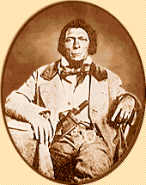
The ruggedness of the area discouraged exploration until the Gold Rush. Spanish exploration in the early 1800’s was limited to the Sacramento Valley. The Hudson Bay Fur Company, however, had entered the Plumas Region by the early 1830’s. Gold miners spread into the area by 1850. Although Indians had known about the Sierra’s lowest pass for centuries, James Beckwourth, (shown at right) an African American, did not formally “discover” it until 1851. Immigrants and miners soon began moving through the pass and into the area. Gold claims around the Project site, camps, and towns such as Pulga and Belden, sprang up along the valley as miners searched for that elusive metal. The towns and remains of several placer mining claims are in the area of this Project, and the remains of mills and works can be seen from the Project.
While mining brought people into the area, other primary production industries allowed them to remain. As the gold fields began to play out, timber and agriculture became the mainstay of the economy. President Theodore Roosevelt established the Plumas National Forest in March 1905. Its boundaries roughly encompass areas surrounding the branches of the Feather River.
The immediate area of the Project is a beautiful narrow gorge on the North Fork of the Feather River. The project area has been heavily modified, first by gold miners, later by railroad and highway engineers, and finally by the crews who built the dam and its adjacent construction yards. The dam and immediate storage areas are built on an area cleared to bedrock. The project area contains the dam next to the modern (1949) alignment of State Highway 70, and a small work area between the road and the dam. All project works including transmission will take place in these areas. There is no possibility of affecting pre-industrial remains in the area affected by this project. No cultural resource impact of any kind is expected.

Natural Resources

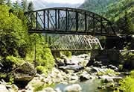
Scenic Beauty and Aesthetics
Feather River National Scenic Byway is a 130-mile route featuring incomparable engineering integrated with natural beauty and diversity in terrain, landscape, wildlife habitat, and human usefulness. Designated for hydropower and engineering in the area as well as for its natural beauty, it is an awesome juxtaposition of 20th century train and hydropower engineering, and incomparable scenery.
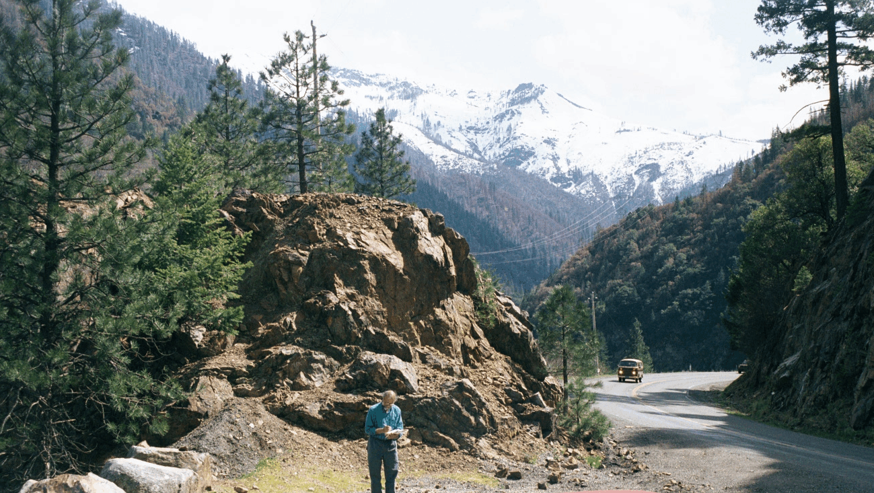
Any season provides unique views of the contrast between man’s small steel and concrete structures and magnificent mountains. Trains rattle up the valley constantly, filling the huge space with rumblings echoing off the canyon walls. In the spring there are nearly 100 waterfalls, brilliant wildflowers, and brightly colored boats of daring kayakers riding the whitewater. In the summer, the sun sparkles off the river as swimmers, fishing enthusiasts, and gold miners enjoy the cool water. The beautiful fall colors along the steep mountain slopes make autumn spectacular. In the winter, the river rushes and the snow-capped mountains contrast sharply with the granite and slate at river level, while man extracts tremendous amounts of hydroelectric power by moving most of the river from reservoir to powerhouses through long tunnels invisible within the granite Mountains lining the valley.
Visually, this Project would have a 12’x16’ square masonry switch house and pad mounted transformer in the area next to the dam. The penstocks and turbines would be visible on the downstream dam face. The trash rack would be less obvious, and out of sight for most observers.

Animal Resources
The Project is on a dam face in the narrows of a very steep gorge. While there are extensive natural resources in the surrounding Plumas National Forest, natural resources in this part of the industrial site are limited to waterborne species. Extensive management plans and studies are underway for many species, from invertebrates to eagles, incorporated in the Project 1962 License. None of these would in any way be influenced by this project except possibly fish. Therefore the fish, fish habitat, fish disease, flow control for fish, water temperature and quality, are the focus of most of the key documents in the Project License, and will be discussed here.

Fish Habitat
The baseline work on fish in this area is contained in the ROCK CREEK-CRESTA Project (FERC 1962) Fisheries Management Study, North Fork Feather River, California July 1, 1988 (Management Study). This study was prepared by the California Department of Fish and Game and the Pacific Gas and Electric Company. Additional survey work focusing on game fish habitat was done by Enplan, who more recently sampled the species in the Rock Creek Reservoir. Enplan specifically addresses the reasons, other than diseases, for the near lack of trout in this area. This survey focused on the number of fish in the reservoirs above Rock Creek and Cresta Dams and discusses the causes for finding so few game fish.
In the immediate Rock Creek Reservoir, according to the Enplan survey, the predominant species were hardhead, with only 3 trout caught using electro fishing and gill netting. The main non-disease problem in this area, identified by Enplan and others, is that the habitat of the River has little gravel and few riffle areas needed by trout. The Management Study found that trout are found primarily in the tributary streams, where they spawn and live. The main stem has few trout within the Rock Creek and Cresta reaches due to the lack of suitable gravels. The reach is dominated by scoured large boulders and reservoirs, with very few riffle areas or low velocity areas with shelter from predators. The CDFG surveyed the reaches and reported in 1988 that only 0.1 % of the area has suitable spawning areas (Enplan). The spawning area problem, coupled with disease in the area, severely limits fish in the main stem of the River and specifically in the reservoirs above, and the reach below, the Rock Creek Dam. These factors have been addressed in the past by intermittently restocking the populations in this area with disease resistant fish. Juveniles are common in the tributaries but are not found in the main stem. Currently, there are extensive studies of fish and fish habitat going on as part of the Agreement under Condition 7.
Specific to our project, the area in front of the trash rack is between 30 and 50 feet deep and the trash rack is on an exposed, barren, vertical face of the dam. This stem/reservoir area is singularly devoid of habitat, shelter, and feeding opportunities that might attract adult or juvenile fish.

Disease
Informal preliminary meetings with the US Fish and Wildlife Service, the US Forest Service, and California Fish and Game, suggest that the key issues for fisheries resources and in particular for trout at the site for the Project outlined in this consultation are flow and disease. They reported prevalence of the disease Ceratomyxa shasta, which primarily impacts the fish in the main stem of the river. Wood in 1979 showed that C. shasta is often found in reservoir environments typical of this river section. The causes and lifecycle of this disease are unclear, however, high water temperature is a contributing factor to its prevalence. The main stem area has significant temperature problems that are being addressed in the Agreement, and over which this Project has no influence. The fish pass downstream from this reach to the Oroville Dam. They have been been identified as a source of the disease in the Oroville Salmon Hatchery below this dam (Keffe). Because restocking, resistant species, habitat improvements, and disease controls may change this premise, the existing and proposed methods of dam passage are now discussed.

Spillway Mortality
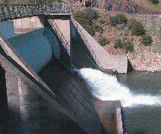
Spillway mortality and morbidity are caused directly by physical damage due to spillways, and indirectly from the dissolved gas that is created when a spillway discharge overly mixes air into a stilling basin. Physical spillway mortality is documented by Larinier as varying widely, from 0-4% at Bonneville to a reported high of 37 % at the Lower Elwha dam.
Indirectly, spillways, and especially jets into basins increase dissolved gas supersaturation (DGS) that causes morbidity and mortality in fish. Super-saturated levels of dissolved gas can be produced at spillways due to the driving of bubbles deep into the stilling basins downstream. The resulting high levels of dissolved oxygen and nitrogen can cause serious injury or death to fish exposed to this condition (Larinier, Fidler. et al., Scholz).
An environmental benefit of this project will be the reduced levels of spillway mortality and total dissolved gas pressure (TGP) downstream of the project by reducing the flow from the jet into the stilling basin and flow down the spillway.

Turbine Mortality
Healthy adult trout will, uncommonly, pass through a small hydro facility, as is evidenced by the prevalence of excellent trout streams with resident brown and rainbow trout in numerous small hydro dams in the eastern United States. The stream areas near these hydro facilities have the best trout fishing in the area, with many small hydropower rivers supporting native populations of trout including rainbow.
A percentage of fish, of any size, that pass through the reaction turbines will suffer varying amounts of mortality. There will be small fish passing downstream as juveniles. It is expected that they will suffer approximately a 3-12% mortality depending on their size, and no feasible sized trash rack spacing will stop them because many will pass through a very narrow slit. If the downward migration of these small fish were stopped with a very fine trash rack, the areas below the dam would suffer declining restocking opportunities. The Enplan survey, done by electrofishing and gillnetting, was unable to find any small trout in the Rock Creek Reservoir, and only found three large ones. The earlier Fisheries Management Study of June 1982 trapped and caught three trout. During a later study conducted in the first half of 1984, two trout were caught during 53 trap days.
During informal Stage 0 consultation with agencies, trash racks and turbine mortality was of considerable interest. To address that interest, Attachment IV is included as a review of turbine and trash rack mortality studies.

Fish Populations: Summary
Dams change the sediment transport, and therefore the habitat along the rivers. The removal of gravel from the river beds dramatically changes the habitat and reproductive carrying capacity of the streams. Eastern micro-hydro sites typically have small dams (from the textile/wood/paper mill days) with no bypass diversion reach. These dams typically “silt up” quickly, and pass all new sediment down stream. While this sediment is a problem in the turbine works, it solves the habitat problem assuring a ready supply of gravel in many micro-hydro installations. This contrasts with the North Fork of the Feather River.
At Rock Creek, the game fish population in the upstream and downstream reaches is limited by habitat (Enplan), disease, and the related issue of temperature, which dictate the carrying capacity of a region. These factors are unlikely to be influenced by small changes in the passage survival of juvenile fish. These factors effectively limit population in these reaches of the river. Currently, juvenile fish pass downstream in several ways:
- in floods that overtop the spillways,
- through the existing trash rack,
- through the outlet jet, and through the sluiceway gate.
For most of the release volume, our Project will substitute the turbines for most of the current release using these methods.
Davis Hydro recognizes as a goal the enhancement of the environment and especially fisheries in this area. We recommend that we work with PG&E to effect any improvements to the habitat that are possible. We recognize that the turbine passages will cause more mortality than spillway passage, but this is unlikely to be observed given the very small populations present.

Recreation
Recreation at this site is dictated by the operation of FERC project 1962. This project in isolation has no direct or indirect recreational opportunities, as the public is ill advised to pass in the area just above or below the dam. Above the dam the public is dissuaded from approaching the water diversion inlets and spillway gates because they open without warning. Below the dam, the public is advised to avoid the gorge area due to the potential for rapid increases in flow releases.
In balancing, recreation and hydropower, Davis Hydro recognizes its obligation to promote recreation in the area. Therefore, it is suggested that Davis hydro work with PG&E to support PG&E’s efforts in this area, in a mutually agreeable manner.

Existing Physical Structure
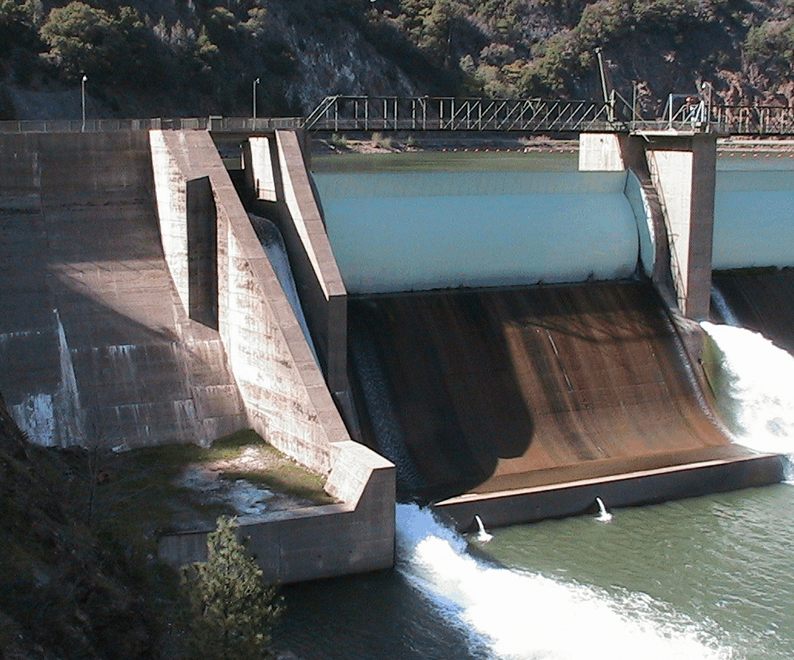
The project is located at, in, and on, the Rock Creek Diversion Dam, located in Plumas County at approximately milepost P-12.3 of California Route 70. The dam‘s physical composition was described originally in PG&E drawings 402281 and 402282, with updated elevations and corrections in PG&E drawing 451770.
The dam is constructed of concrete, with steel spillway gates. It is 126 feet high (stream bed centerline to top of cement), and has a 550 foot crest length.
It is a concrete gravity dam built in approximately 1949 and is in excellent condition. It has two major 124’ spillways. Each spillway has 28’ drum gates, maintained at a raised elevation of 2,216 feet. There is also a smaller 22.5 feet wide fixed spillway at fixed elevation 2201.2 (all above MSL USGS datum NAD-29). The picture to the left shows the fish instream release on the right. The western drum gate is in the center and the operating sluiceway and the area for the turbines are on the left, and shaded.
There is about 14 feet of freeboard from the main spillway gates when they are up, and 42 feet when down. There are three unused low-level gated outlets of 7’8” inside diameter. There is one recently installed 30” high level outlet, with a trash rack with 2 5/8^{ths} inch spacing, exiting near the center of the spillway face. Finally, there is a 22.6’ wide sluiceway used in combination with the 30” discharge for fish and recreation instream releases.
There is one other detached structure – an inlet structure to the rock creek diversion tunnel. This diversion operation is critical to the operation of the Rock Creek section FERC Project 1962.

Proposed General Engineering Design
Starting upstream, Davis Hydro would likeproposes to install the following equipment.

Trash Booms
PG&E’s trash boom (see next picture below) would be moved slightly to the left to allow placement of the new trash racks. A new trash curtain would be run from the diversion structure from the same point near the sluiceway. A second new small trash boom will extend from the shore to the upstream end of the existing Project 1962 diversion inlet, parallel to its face.

Trashrack and Inlet
A new trash rack will be installed on a recessed wall of the dam (at the white spot on the wall) to the North of the sluiceway. This area is quiet and out of all flows. The picture shows the existing log boom on the right the 22 foot sluiceway. This log boom will be moved slightly toward the sluiceway shown on the left.
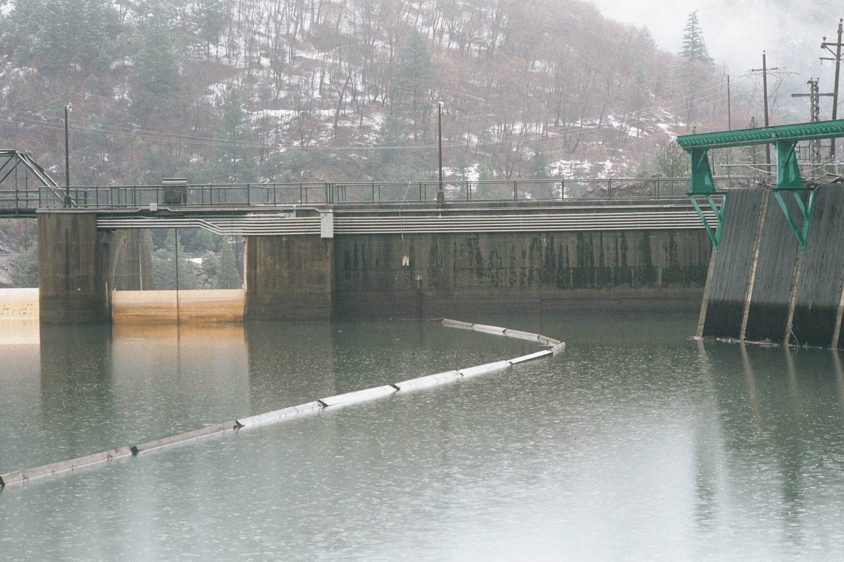
This picture looks downstream on the north or road side of the dam. The large structure on the right of this picture is the existing trash rack covering the diversion down to the Rock Creek Power House. The proposed trash rack will be placed exactly at the center of the picture at the end of the existing log boom. It will have a bar spacing as approved by FERC. Trash rack spacing is proposed at a maximum of 1.75 inches between bars, with a maximum face approach velocity of .65 feet per second or less.
There will be new inlets through the wall of the dam, near the road behind the new trash rack. These will have a diameter of just over 4’ on the downstream end and ellipse-shaped holes on the upstream end to clear the inside of 5 foot by 7’ slide gates. There will be a trash rack cleaner on the top of the dam next to the trash rack, smaller, but somewhat similar to the one shown on the existing diversion.

Fish Diversion

Compared with the minute technology of upstream fish passage, downstream passage technology remains experimental. Except for spill, the variety of the physical and behavior approaches to downstream passage has met with about {3 to 87%} success. Levels of effectiveness exceeding 50% passage are difficult to achieve, or if achieved, are difficult to sustain. The technology for downstream passage of anadromous fishes is not mature, and additional research is needed to identify suitable alternatives that have applicability across sites. Also needed are suitable measures to divert and bypass resident species away from turbine intakes.
FERC, 2003

Diversion Penstocks:
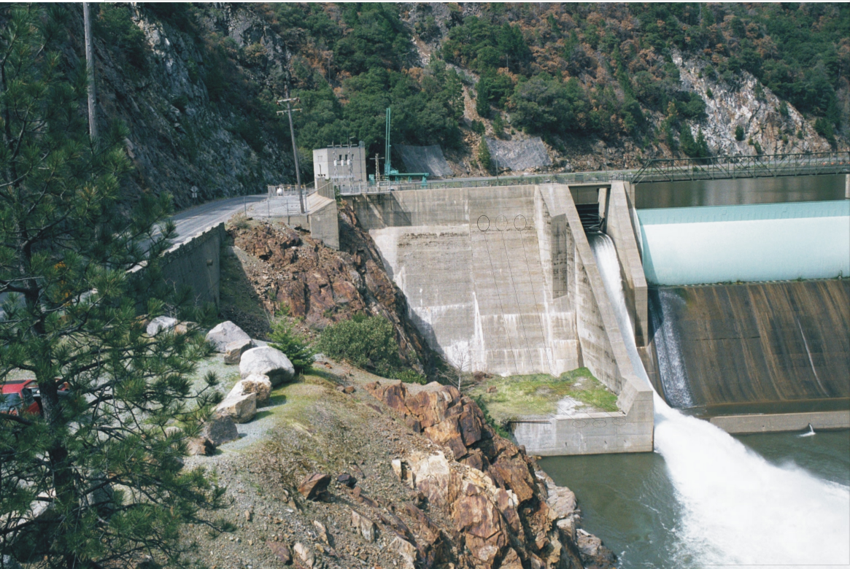
There will be three new 200’ steel penstocks with a 42” diameter from the new trash rack on the west (highway) side of the dam down to a turbine area on a curtain wall of the dam.
The penstocks will have air vents to act as vacuum breakers rising above the dam top, and will have a secure walkway down the downstream face of the dam to the turbine area. The three turbines would be mounted on the downstream wall to the left in this picture of the operating sluiceway. The work area is on this curtain wall and the adjacent flat area (shown with green grass cover). The top of the curtain wall is about 17’ feet above the stilling pond. The proposed total maximum discharge will be 280 cfs with a working net head of about 88 feet. The switch house would be behind the distribution pole in the top left of this picture.
Please note that this project area is completely isolated from PG&E’s operations.

Turbines
Three Francis or mixed flow turbines will have a capacity of 150 cfs, 80 cfs, and 50 cfs, respectively Each of these would be independent and have a single transformer and connection to the existing 12 kV transmission at the dam in common.

Generators and Interconnection
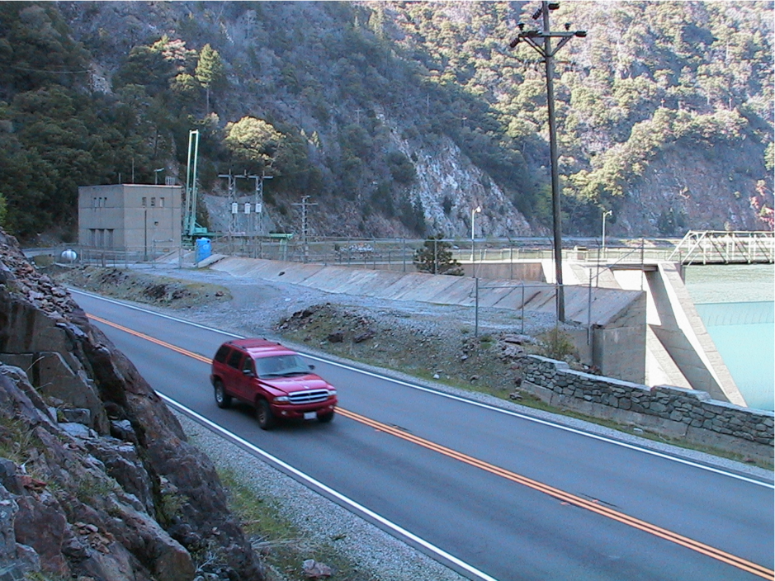
The new proposed transmission line would be about 30 feet up to a distribution line on-site. It would connect the switch and control house near the road to the transformer up to the existing distribution line directly overhead. The transmission interconnection point is on-site. The new proposed generation at the site would be at 2,400 volts and would be transformed to primary voltage in a pad-mounted vault located at the base of the pole. Shown in the picture is the site of the control/switch house, directly to the left of the existing distribution pole. The proposed turbines are to the right and down, out of sight from this view.

Operation
There is one impoundment related to this application, the Rock Creek Reservoir. It is an 80 acre reservoir at 2216 feet elevation. The storage capacity is 4,669 acre-feet at normal maximum surface elevation of 2216.2 feet. No changes of any kind are proposed to this reservoir. The site will be operated Run-of-River by PG&E, or under their direction, as is convenient to them. All organic “woody” would be returned to the river, as its decomposition contributes to habitat maintenance.

Stream Flow and Water Regime
Since this is a run-of-river project, flow through this area is controlled by PG&E who releases water under the Settlement Agreement flows, as codified into their new License. Since our diversion is from the PG&E releases, the appropriate reference document is the FERC license 1962 flow requirements. Since under the Agreement these flows are subject to changes depending on water availability and environmental conditions, the appropriate method to generate the stream flow data used in the engineering is to refer to the settlement conditions imposed in the Project 1962 license.
The total estimated average annual energy production and installed capacity is:
- 88 feet of net head – subject to PG&E’s operations
- 280 cfs max flow – subject to PG&E’s releases
- Three initial hydro generators would be used with a total nameplate capacity of 1.75 kW at 88’ feet of head. Expected average annual production would be 10.6 GWH. All turbines and generators are proposed as new. None exist.

Table 1. Proposed Turbines and Generators:

Generator | CFS @ | Design Head (feet) | KW(design net) | KW Capacity
#1 | 50 cfs | 89’ | 297 | 300
#2 | 90 cfs | 88’ | 535 | 600
#3 | 150 cfs | 87’ | 892 | 900
Total | 290 cfs | 88’ median head | 1,724 | 1.8 MW
The capacity of the site is limited by head and flow determined entirely by PG&E operation under their FERC License. This will be a run-of-river operation on whatever flow PG&E or a future licensee is required to release.
(5) Lands of the United States are enclosed within the proposed project boundary and include parts of Plumas Forest. The entire project is surrounded by the Plumas National Forest. To the south of the project is the Bucks Lake Wilderness.
(6) The proposed project would develop, conserve, and utilize in the public interest, the water resources of the region. This is a simple dam based release power recovery project. It would use the required run-of-river dam based release for power production under the Project 1962 License. This generation will reduce the need for fossil fuel power generation in the West, and will slightly lessen the burden of the bypass flow. The project will provide PG&E with another set of tools to accurately maintain the bypass flow below the Rock Creek Dam.
(4) The North Fork of the Feather River is not included in the National Wild and Scenic Rivers System. It is not wild, but controlled both for beauty, safety, and utility by PG&E.

Mitigation:
Having obtained an estimate of passage effectiveness, it is important to be able to compare it with some criterion of acceptability. What does a passage efficiency of 50% for an anadromous species mean to the restoration of the stock in that river basin?
FERC 2003

The project has environmental benefits and costs. This project is designed to piggyback onto Project 1962, and as such will not interfere in any manner with its operation. The Rock Creek Retrofit Project will pass fish, and notably young trout. When healthy trout repopulate the Rock Creek Reservoir our turbines may have a more negative impact on these fish than current dam passage procedures. The decrease in potential Gas Bubble Disease from dissolved gas supersaturation (DGS) from the current release mechanism will partially offset detrimental effects of the turbines. Currently, there are very few fish in the Rock Creek Reservoir due to its poor shoal gravel conditions, high presence of C. shasta in these reservoirs, and poor habitat. Nevertheless, with Settlement related improvements in the eco-system, healthy fish may return, and this DGS mitigation may be useful.
To mitigate any potential impacts this new release mechanism may have, Davis Hydro would be pleased to discuss the following additional mitigation measures to effect fish enhancement in the Northern California Area:
- Continue to work with UC Davis on fish passage research for low head hydro. Currently innovative design efforts are focusing on open channel micro hydro installations primarily applicable in open rivers.
- Work with the Bureau of Reclamation to design and building a nature-like fish bypass for Red Bluff Dam. Davis Hydro believes that a nature-like bypass is both economical and practical at this site, and will work with interested parties to have it seriously considered.
- Continue research on fish guidance to bypass facilities, and attraction methods to improve fish passage at all dams. (See CEC project description on DavisHydro.com).
- Plant low bushes along both sides of the Rock Creek Reservoir to improve the near-shore habitat. This would be done under the advice and direction of CFG.
- Work under the direction of PG&E to assist with any environmental measures related to this project.
- Provide, if requested by PG&E, the accurate real time data on minute by minute releases to PG&E operators. This will allow them much finer control of discharges at all times.
While most of these measures are not directly related to this project, there is only a limited set of opportunities within this project itself. Davis Hydro is committed to enhancing the environment through responsible micro hydro.

Recommended Studies

No fish passage mitigation should be implemented without extensive consideration of the need for studies to assess the effectiveness of that mitigation.
FERC 2003

Currently completed is a 20 year sequence of studies, that culminated in the License. Since the issuance of the License, and underway currently, is a continuing series of studies on fish and fish population, catch, habitat, invertebrates, flow, recreation, temperature etc., that are monitoring every aspect of this site. These studies will be conducted every year for 15 years. PG&E, has filed on July 30th of last year the Fishery monitoring plan which is extensive.
The only feature unique to this piggyback retrofit project is the turbines and their associated mortality. Since this cannot be studied until after operation begins, this must be studied in advance in the literature. A literature review is presented in Attachment IV. There is nothing that this applicant can add to that literature. In summary, Davis Hydro suggests that no separate further studies are warranted for this retrofit project, beyond those currently underway.

Monitoring:
.
All license articles requiring upstream or downstream fish passage {should} also include an effectiveness monitoring plan as part of that requirement.
FERC 2003

Because there are only a small number of game fish currently active in the Rock Creek Reservoir, and because the factors that control their viability: habitat, disease, and put and take operations overwhelm any impact of the differential mortality of spillway/jet vs. turbine mortality. Meaningful studies of the effects of fish passage of resident or quasi-resident species would be difficult at this time. Currently, under the License Monitoring Program in Appendix B section 5 of the Settlement Agreement there is extensive stem and Creek fish monitoring for 15 years. Davis Hydro will participate with PG&E in Condition No. 7 (Fishery Monitoring Plan) of their License if requested.

Other Concerns:

Other Hydropower Alternatives:
Consideration has been given to several other configurations:
- Excavating the low level outlets and using them for hydropower: This alternative has the problem that the outlets are buried under many feet of gravel. Evaluating the environmental impacts of moving that gravel are beyond this Project’s potential.
- Digging a narrow channel around the dam and putting a covered headrace under the road to a new powerhouse. This alternative is unrealistic in that the road is on bedrock in this area, and a headrace would have to go over the top of the current diversion tunnel. Further, because it would mean blasting and digging through many of feet of rock that forms the support for the dam and road, major dam safety and cost questions would be raised.
- Siphoning over the top of the dam after building it up slightly. This alternative is still possible with a cost not obviously different from the proposed design. Raising the dam on this side by 3”, with wide oval shaped siphons over it, is physically possible, but the whole area would have to be raised so as not to impede access to the dam from the wall. This will be discussed with PG&E when the engineering consultation is undertaken.
- Two Penstocks and turbines instead of three. This alternative is under serious consideration. All other factors would be the same, except that there would be two larger turbines and generators instead of the proposed three. The down side is that this area is hard to reach with cranes, and larger equipment would be more unwieldy to install and repair. Also the transmission in this area might be a limiting factor, and smaller generators cause smaller transients on the line than larger ones. This will have to be resolved during PG&E’s engineering review.
- Gravel Passing Turbine: This alternative involves installing a tougher turbine type that can accept some gravel and use this to pass gravel downstream. This alternative is under consideration to help PG&E meet Condition No. 14. It suffers in that the cost of the trash rack, intake, and turbine have to be tougher to withstand the continuous stream of gravel through the system. Further, since gravel of only an intermediate small size will pass for a given wear rate on the turbine runners, larger cobbles will have to be passed over the dam another way – over the dam with a larger trash rack, or down the present diversion. This is not difficult, be will require a more expensive trash rack assembly and a wider spaced trash rack than suggested for just the fish. There are also operating and maintenance issues.

PURPA Benefits
The applicant will not seek benefits under section 210 of PURPA.

Bibliography
FERC Project 1962 Related Bibliography and Discussion Documentation
(Chronological)

Documents

September 28, 1979 PG&E files its application for a new License on Project 1962

April 8, 1981 Cultural Resource assessment for the Rock Creek – Cresta Water Project Area

May 1981 PG&E Applies for an Amendment of Application for New License for FERC Project 1962

July 23,1985 Amendment to PG&E’s Application. (This Application amendment was to put micro-hydro hydropower at the dam. This was somewhat similar to this proposal, but at a scale appropriate for the instream flow releases at the time.)

July 1, 1988 Rock Creek- Cresta Project Fisheries Management Study, North Fork Feather River, California by the California Department of Fish and Game

May 1995 Scoping Document Rock Creek-Cresta Hydroelectric Project, FERC Project 1962, Environmental Assessment by the FERC.

October 1994 Technological Report Habitat and Fish Species Composition in the Poe Reach NFFR, and Fish Species Composition in Rock Creek, Crest and Poe Reservoirs, by Stacy, D. Li. Aquatic Systems Research, subcontracting to Enplan, for PG&E.

November 1, 1996 FERC completes and makes available its Draft Environmental Assessment on Project 1962 – Extensive discussions of stocking area with Shasta Disease resistant trout between Belden and Poe

November 29th, 2000 Rational Report for the Rock Creek– Cresta Relicensing Settlement Agreement

December 2000 Rock Creek – Cresta Relicensing Settlement Agreement

October 24th, 2001 FERC, Order Approving Settlement and Issuing New License

July 22, 2002 PGE’s Fishery Management Plan accepted by the ERC.

Reference Dates and Project Discussion Documentation

May 3rd 2001 | FERC issues Davis Hydro a Preliminary Permit for additional Capacity at FERC Project 1962:
Fall Winter 2001 | Informal meetings and conversations with CDFG (MM), FS, CDWR. USFWS, PG&E (San Francisco), and Plumas County Planning
December 6th 2000 | DH files for a Water Right Permit
March 9th, 2001 | PG&E intervenes on Davis Hydro’s Preliminary Permit
March 21, 2001 | Responses to interventions of Shasta Paddlers, PG&E, and others filed by Davis Hydro with the FERC
March & April 2001 | Numerous phone discussions with Michelle Johnston and associates at PG&E
April 17th 2001 | Meeting With PG&E Field Engineers in Sacramento.
June 1, 2001 | Letter from Forest Service discussing Special Use permits, Surveys, and that the FS is supportive of hydroelectric.
June 14, 2001 | Letter from PG&E indicating that they will continue discussions … regarding the use access to PG&E facilities.
September 12, 2001 | Letter from PG&E indicating that “ they have an interest in {the project}, but will need to review the engineering extensively”. Suggests a “facility use fee”.

Fish Passage References

Bell M. C., Delacy A. C., 1972. A compendium on the survival of fish passing through spillways and conduits. Fish. Eng. Res. Prog., U.S. Army Corps of Eng., North Pacific Div., Portland, Oregon

Cada, G. F., C. C. Coutant, and R. R. Whitney. 1997. Development of biological criteria for the design of advanced hydropower turbines, DOE/ID-10578. Report Idaho Falls

Cada, G. F. 1990. A review of studies relating to the effects of propeller-type turbine passage on fish early life stages. North American Journal of Fisheries Management 10(4):418-426.

Cada 2001: The Development of Advanced Hydroelectric Turbines to Improve Fish Passage Survival September 2001 Fisheries 26 (9)

Cada, G. F., C. C. Coutant, and R. R. Whitney. 1997. Development of biological criteria for the design of advanced hydropower turbines. DOE/ID-10578. Report, Idaho Falls

Cech, J. J. Personal Communication 2003 Davis

Duke Engineering & Services, Brilliant Expansion Project Fish Passage Feasibility, Report March 2000, Seattle

Ely, R. Recent FERC Rulings and Settlements of Trash Rack design – Spacing and Flow, 2003, Davis (Voluminous, available under Rock Creek Documents on Davishydro.com )

Enplan: See Li

EPRI, 1992. Fish Entrainment And Turbine Mortality Review And Guidelines. Report Stone And Webster Engineering Corporation, Boston

FERC Scoping Document 2 Upper North Fork Feather River Hydroelectric Project California FERC Project No. 2105-089 FERC August 2003, Washington, D.C.

. _____. Evaluation of Mitigation Effectiveness at Hydropower Projects, Fish Passage. Draft Report September 2003, Washington

Fickeisen, D.H. and M.J. Schneider Gas Bubble Disease Workshop Proceedings Richland Washington, October 1974, NTIS ER 1.11:CONF-741033,, Washington

Fidler, L.E. S. B. Miller, British Columbia Water Quality Guidelines for Dissolved Gas Supersaturation, BC Ministry of Env., by Aspen Applied Sciences Ltd. 1994, Valemount, BC

Keefe, M. L. Oroville Facilities Relicensing (Project No. 2100) Sp-F2, Phase 1 Interim Progress Report Sp-F2. Evaluation Of Project Effects On Fish Diseases, Review Draft Report, Harza Engineering 2002, Chicago

Larinier, M. Dams and Fish Migration, Report , Institut de Mechanique des Fluids, June 2000, Toulouse

Li, Stacy D. and Enplan, Habitat and Fish Species Composition in the Poe Reach NFFR, and the Fish Species Composition in the Rock Creek, Cresta and Poe Reservoirs, Enplan Report 1994 Redding

Marmulla, G. (ed.), Jackson, D.C. Dams, fish and fisheries. Opportunities, challenges and conflict resolution. FAO Fisheries Technical Paper. No. 419. FAO. 2001, Rome.

Normandeau Associates, Inc., J. R. Skalski, and Mid Columbia Consulting, Inc. 1995. Turbine passage survival of juvenile spring chinook salmon (Oncorhynchus tshawytscha) at Lower Granite Dam, Snake River, Washington. Prepared for Walla Walla District, U.S. Army Corps of Engineers, Walla Walla, Washington

. _____. 1996. Fish survival investigation relative to turbine rehabilitation at Wanapum Dam, Columbia River, Washington. Prepared for Grant County Public Utility District No. 2, Ephrata, Washington

_____. 1999. Relative passage survival and injury mechanisms for chinook salmon smolts within the turbine environment at McNary Dam, Columbia River. Prepared for Walla Walla District, U.S. Army Corps of Engineers, Walla Walla, Washington.

_____. 2000. Direct survival and condition of juvenile chinook salmon passed through an existing and new minimum gap runner turbines at Bonneville Dam First Powerhouse, Columbia River. Portland District, U.S. Army Corps of Engineers, Portland

O'Neal Richard P., Muskegon River Watershed Assessment. State Of Michigan Department Of Natural Resources Number 19, Special Report July 1997, Ann Arbor

Pavlov, D.S. A. I. Lupandin, VV Kostin Downstream Migration of Fish through Dams of Hydroelecric Power Plants, Rus. Acad. Sci. 1999, Moscow

Ruggles, C. P., and D. G. Murray. 1983. A Review of Fish Response to Spillways. Canadian Technical Report of Fisheries and Aquatic Sciences No. 1172. Ottawa

Scholz, Allen P, Presentation at Columbia Basin Trust workshop on Ecosystem-Based Management, Castlegar 1998

USACE (U.S. Army Corps of Engineers), 1995. Proceedings: 1995 turbine passage survival workshop. U.S. Army Corps of Engineers, Portland District, Portland, Oregon.

Wood, J.W. 1979. Diseases of Pacific salmon - their prevention and treatment. State of
Washington Department of Fisheries, Hatchery Division.

Attachment I Drawings

Drawings are supplied in a format that should print on an 11” by 17” printer.
Also available as electronically separately in graphics formats.

Figure I Section
Figure II Plan
Figure III Elevation
Figure IV Location

This Project is located at the Rock Creek Diversion Dam identified in FERC Project 1962
Project boundaries, townships, and property Ownership are identical and shown in Exhibit G –3 and G-4 of that Project. Copies of these Exhibits are submitted here for reference.

Figure V PG&E’s Exhibit G-3 from Project License 1962
Figure VI PG&E’s Exhibit G-4 from Project License 1962

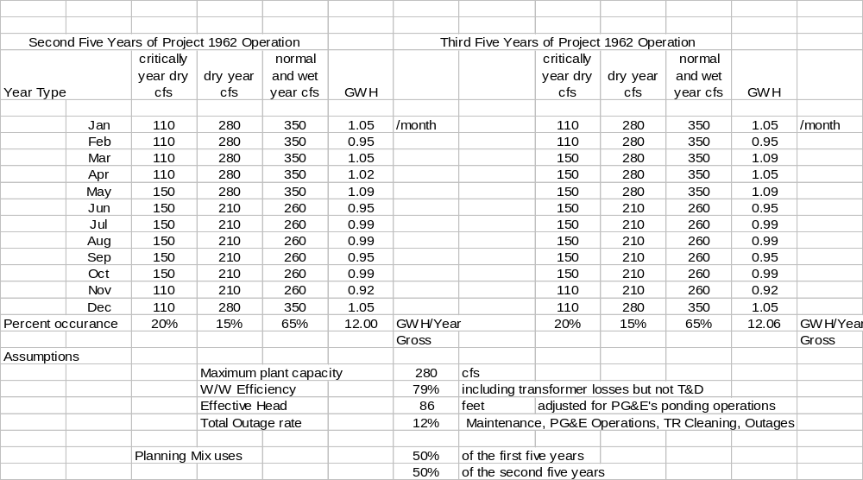Attachment II - Flow and Use Data
Flow Data Extracted from Tables A.2 and A.3 in the FERC Project 1962

Attachment III - Regulatory and Project Information

Site Information

This information is supplied for agency and stakeholder review, and is intended to be used eventually in the License Application. The paragraph numbers below refer to section of the License application where the information will be used.

Owner of the Dam: PG&E - a domestic corporation:
Office of the Director, Hydropower Generation
Attn: Mr. Randy Livingston, Director
245 Market Street, San Francisco, California 94105

(a.2.i) Plumas county:
Board of Supervisors
Courthouse, 520 West Main Street, Quincy, CA, 95971

Local FERC Office is:
Mr. James Goris, Regional Director
cc: Mr. Jerry Lutticken, Project 1962
Federal Energy Regulatory Commission, Suite 350
901 Market Street, San Francisco, CA 94103

a.2.ii – Towns with population greater than 5,000 in 15 miles: None
a.2.iii – Irrigation districts, etc. None
a.2.iv – Other political subdivisions affected : None
a.2.v – Indian Tribes: None

a.3.i This applicant will make a good faith effort to give notification by certified mail of the filing of the application to:

- Every Property Owner within the bounds of the Project, underlying the project, or adjacent to any project works including any impoundment.
- Any potential interested local, municipal, state or federal agencies

a.5.ii see § 4.61

1. The Applicant, Davis Hydro, LLC, will apply to the Federal Energy Regulatory Commission for a License for the Project, as described hereinafter. Currently identified with a preliminary Permit as FERC Project 11866 held by Richard D. Ely, DBA Davis Hydro.

2. The Location of the Project is: in the State of California, Cou nty of Plumas, near Belden, on the North Fork of the Feather River between the Opapee and Murphy Creek tributaries at, and on, the Rock Creek Diversion Dam.

3. The exact name of the applicant is:
Davs Hydro, LLC
27264 Meadowbrook Drive, Davis, California,
530 753-8864, Fax 530 753 4707
hydro@davis.com

4. The authorized agent is
Richard D. Ely, member Davis Hydro, LLC
29264 Meadowbrook Drive, Davis California
530 753-8864, Fax 530 753 4707
hydro@davis.com

5 The applicant is a Limited Liability Company and is not Claiming Preference under section 7(a) of the Federal Power Act.

6.i The statutory or regulatory requirements of California in which the project would be located that affect the bed and banks and the appropriate Diversion, and use of water for Power Purposes, and with respect to the right to engage in the business of developing, transmitting, and distributing power and in any other business necessary to accomplish the purpose of the license under the Federal Power Act are:

- Fish and Game code
- California Water code (Diversion Permit)
- The California Environmental Quality Act
- 401 Water Quality Certificate by designee: the Department of Water Resources Control Board
- CPUC Public Utilities Code

7.i Proposed installed Generation Capacity 2.5 MW for Licensing. Initially 1.8 MW of turbines will be installed, and provision made for upgrading depending on future operation by PG&E. We will be requesting 2 MW capacity transmission from PG&E which is about 10% more than anticipated power available for the proposed turbines.

7.ii This project is at an existing dam

8. Lands of The United States Affected: The Plumas National Forest. The land is surveyed.

9. Construction is planned to start within 18 months and be completed within 60 months of the date of issuance of the license.

License Exhibit A Information

C.1.i Turbines and Generators to be installed

Generator | CFS @ | Design Head (feet) | Kw (design net) | KW Generator Capacity
#1 | 50 cfs | 89’ | 297 | 300
#2 | 90 cfs | 88’ | 535 | 600
#3 | 150 cfs | 87’ | 892 | 900
Total | 290 cfs | 88’ median head | 1,724 | 1.8 MW

C.1.ii Reaction turbines will be used. If possible, Kaplan or mixed flow turbines, but current design is for a Francis turbine that may be necessary due to physical geometry available at the site.

C.1.iii: The plant will be operated automatically under the direction of (or control of) the PG&E company. The plant will be operated Run of River on PG&E’s water releases in Project 1962. A flow duration curve will be provided in the license. It contains only the information in the Order.

Description of the drainage area is enclosed by reference to the Project 1962 License and supporting documentation. It is not relevant here because this project will be operated run-of-river using only a very small part of the available flow.

C.1.iv Annual production is expected to be 10.6 GWH.

C.1.v The estimated net head on the plant will be 88 feet – varying with PG&E’s operations. Gross head varies, but is about 92 feet.

c.1.vi Reservoir characteristics: See above.

C.1.vii.a The estimated Hydraulic Capacity is dictated at this site by the flow regime releases codified in Tables A.2 and A.3 of the Order Approving Settlement and issuing New License 1962.

C.1.vii.b A flow duration curve will be supplied in the License Application.

C.1.vii.c Description of the drainage area. Reference is made to the Description in License 1962. However, this is a run-of-the river plant on the instream release required at a major diversion. The characteristics of the “drainage area” are best defined by the required release schedules shown in tables A.2 and A.3 of the Order Issuing License for Project 1962.

C.1.ix The estimated cost of this Project is estimated at 1.9 million dollars

C.2 The purpose of this project is to generate power for sale.

Suggested License Provisions:

The following Project 4(e) Section 10(a)(1) Terms and Conditions provisions are suggested and accepted by the applicant to be applied to the license. The numbering used refers directly to the numbering used in FERC License for Project 1962:

Project 1962 Provisions & Conditions | Name | Provision Comment
Forest Service  1 | Design Approval | Agreed
2 | Changes Approval | “
3 | Consultation | “
Settlement Agreement  4 | Water Temperature | Defer to PG&E. Will provide 24/7 Temperature monitoring at NFRR below RC dam if asked.
5 | River Flow | *
6 | Ramping Review | No action
7 | Fishery Monitoring | Provide on-site assistance if asked by PG&E.
8 | Riparian Monitoring | *
9 | Macroinvertebrates | *
10 | Fishery Habitat Improvements | Assist PG&E if asked.
11 | Fishery Habitat Monitoring | “
12 | River Terrace Plantings | “
13 | Planting Monitoring | *
14 | Gate Operations | *
15 | Sediment Management Plan | *
16 | Recreation Flow | Assist PG&E as directed
17 | Recreation Flow Evaluation | *
18 | Recreation Stream Flow Information | *
19 | River Recreation Access | *
20 | Shady Rest | *
21 | Public Recreation Monitoring | *
22 | Recreation Monitoring | *
23 | ERC | Participate if asked
24 | Visual Resource Plan | Participate with PG&E as requested.
25 | Transportation System Plan | *
26 | Fire Participation Plan | Participate with PG&E as necessary and as requested.
27 | Noxious Weed Management | Participate with PG&E as necessary and as requested.
28 | Trash & Maintenance | Agreed to same conditions
29 | Existing Claims | *
30 | Compliance with Regulations | Agreed to separately
31 | Protection of US Property | Agreed
32 | Surrender and Restoration | Agreed There will be a similar agreement with PG&E
33 | Self Insurance | Agreed
34 | Water Pollution | Agreed
35 | Damage – High Hazard | Agreed
36 | Risks and Hazards | Agreed
37 | Signs | Agreed
38 | Pesticides | No Pesticides will be used
39 | Access | No roads are to be constructed.
40 | Road Use | Agreed
41 | Hazardous Substance | Agreed to same provision
42 | Heritage Resources | No resources Present

* means No Activity

Attachment IV Fish Passage Discussion
Many river fish (brown trout, rainbow trout, northern pike, smallmouth bass, brook trout, and many other species migrate within the river systems as part of their life histories (Schlosser 1991). These movements are associated with reproduction, foraging, different summer and winter habitat requirements for cover, water temperature, velocities, and depth. Dams inhibit this movement leading to a decrease in populations due in part to simply due to the inhibition of motion of these fish from area to area in a river. Genetic viability of resident and non-resident river species can be decreased by barriers in a river (Kapuscinski and Jacobson 1987) leading to a more fragile population.

Turbine Mortality
For this project the mortality of turbine-passed fish can be compared with current passage. At this site the focus is on trout. Fish passage has been studied most extensively in other fish populations, especially among anadromous species (such as Pacific salmon and steelhead [Oncorhynchusspp], Atlantic salmon [Salmo salar], American shad [Alosa sapidissima]), and catadromous eels [Anguilla rostrata]) that must travel from rivers to the sea in order to complete their life cycles.
Injuries and mortality among fish that pass through hydroelectric turbines can result from several mechanisms, which are described in Cada and USACE 1995, Pavlov 1999, Larnier 2000, and many others. Cada et al’s extensive review in 1997 focused on juvenile salmon. These provide a model for the passage of Juvenile trout, which are less studied than salmon. Perhaps this is because in the salmon, migration is required for survival, while in the trout, they are naturally ranging in a water course, but it is less clear that this is required for survival.
Normandeau et al. reported (1999) turbine mortality between 3.0% and 3.8% depending on where the fish were introduced into the turbines. In 2000 they found that the probabilities of survival for fish passed near the hub were high (0.95 to 97%) in a larger series of tests that included Kaplan and “fish friendly turbines. Duke also reported field studies of Kaplan mortalities averaging at around 5-10 percent, lower than with Francis units. The reasons are unclear, but include a greater head at installations, internally rapid pressure changes, water shear as water makes two turns, and the proximity of the wicket gates to the runner.
Cada in 2001 found overall survival turbine probabilities were similar over a range of Kaplan and mixed flow turbines typical in the Northwest. Typical mortality for salmon smelt, including delayed mortality, in these large turbines ranged between 4 and 5 percent. Pavlov, Cada, EPRI, Marmulla and others report a wider spectrum of studies, and find a larger range of impacts – typically up to and over 15 % but this includes larger fish. Many reviewers report that small fish – the smelt or juveniles - do better than large fish. For comprehensive summaries see EPRI for a 1990 review, and Marmulla for more global perspective on all benefits and costs of the dams in 2001.
Currently, at Rock Creek Diversion dam the instream release outlet is controlled by a butterfly valve, and the water released to freefall into the stilling pond . The remainder of the fish pass through slits under the sluice gate and pass out as a jet to the stilling pond. Bell and Darcy, and Cada (1997) discuss the impact on the fish from this release mechanism both from the impact and from the entrained air. The spillway mortality hazard is addressed for salmonids in Bell and Delacy and more generally in Larinier who cites specific experimental evidence. See also Ruggles and Murray.

Trash Rack Bar Spacing:
Current spacing on the 30” instream fish release at the Rock Creek Diversion Dam is 2 5/8”. This inlet, like the inlet we are proposing, is on the face of the dam away from all feeding or habitat areas. We have a proposed maximum of 1.75 inch clear water spacing design based on a review of FERC decisions (Ely) and Pavlov’s conclusion that screening has very limited capabilities. He points out that screening can only be used for larger fish. Juvenile fish can pass through any trash rack size that is economical. In small hydro, the trash rack in trout streams serves as a hydraulic velocity surge that triggers avoidance in drifting adults (Pavlov et al.) FERC addresses trash rack spacing regularly in its decisions. A recent decision is as follows: Issuance 20021030-3065: On project 6058-005: Order issuing subsequent license re Hydro Development Group, Inc under P-6058,
Our Analysis {FERC’s}
Replacing or modifying trashracks can be extremely expensive and the effectiveness of 1-inch-clear-spaced, angled trashracks has not been conclusively demonstrated for warmwater and coolwater species. Studies conducted at the Upper Greenwich Project, on the Batten Kill River in New York, found that for resident fish (primarily bullhead, rock bass, and sunfish species) 69 percent of the fish moved downstream through the turbines despite installation of angled trashracks designed to meet Interior's specifications (ERC, 1996, as cited in FERC, 2001).

The existing trashracks with 1.75-inch clear spacing are similar to those in many of the studies that EPRI reviewed in 1992 (concluding that most fish entrained are less than 200 mm[approximately 8 inches] in length) and should preclude entrainment of many larger fish. The estimated maximum water velocity at the trashracks is 0.89 fps and 1.64 fps at Hailesboro#4 and Fowler #7 Projects, respectively. With these velocities, most fish should have sufficient burst speed to swim upstream against the prevailing flow and to avoid entrainment (actual burst speeds of individual fish depend on the species and the size of the fish).

Attachment V Contact Sheet

Active Distribution of all Materials
Tom Jereb, Cresta - Rock Creek Relicensing Manager  Pacific Gas and Electric Company  245 Market Street., N11C  P.O. Box 70000  San Francisco, CA  415-973-9320 Fax 973-5323  taj3@pge.com | Jim Edmondson  California Trout  5436 Westview Court Road  Westlake Village, CA 91362  Ph. 818-865-2888 FAX 818-707-2459  Troutmd@earthlink.net
Mark Madrid, Forest Supervisor  USDA Forest Service  Plumas National Forest  159 Lawrence Street  Quincy, CA 95971  Ph. 530-283-2050 FAX 530-283-7717  mmadrid@fs.fed.us | Curtis Knight  California Trout  P. O. Box 650  Mt. Shasta, CA 96067  Ph. 530-926-3755 FAX 530-926-8909  CAKnight@JPS.net
Jack Gipsman, Office of General Counsel, USDA  33 New Montgomery, 17th Floor  San Francisco, CA 94105  Ph. 415-744-3166, FAX 415-744-3170  jack.gipsman@usda.gov | Kevin Lewis  Shasta Paddlers  4641 Hornbeck Ln  Anderson, CA 96007-2631  Ph. 530-2118722 FAX 530-221-5981  klewis@snowcrest.net
Banky Curtis, Manager, Region 2  California Department of Fish and Game  1701 Nimbus Road, Suite A  Rancho Cordova, CA 95670  Ph. 916-358-2899, FAX 916-358-2912  bcurtis@dfg.ca.gov | Dave Steindorf  Chico Paddleheads  179 Valley Ridge Dr.  Paradise, CA 95964  Ph. 530-876-0430, FAX 530-876-1335  dsteind@telis.org
Nancee M. Murray, Legal Office  California Department of Fish and Game  1416 9th St., 12th Floor  Sacramento, CA 95814  Ph. 916-654-3818 FAX 916-654-3805  nmurray@dfg.ca.gov | Mr. Nate Rangel  CA Outdoors  PO Box 401  Coloma, CA 95613-0401  Ph. 530-626-7385 x203 FAX 530-626-9268  nate@raftcalifornia.com
Wayne S. White, Field Supervisor  United States Department of the Interior  Fish and Wildlife Service  2800 Cottage Way, Room W-2605  Sacramento, CA 95825  Ph. 916-414 6610 FAX 916 414-6714  mailto:Wayne_white@fws.gov | Kelly Catlett  Friends of the River  915 20th Street  Sacramento, CA 95814  Ph. 916-442-3155, FAX 916-442-3396  jen@friendsoftheriver.org
Jim Canaday  State Water Resources Control Board  1001 I Street P.O. Box 2000  Sacramento, CA 95814  Ph. 916-657-2208, Fax 916-657-1485  jcanaday@waterrights.swrcb.ca.gov | John Gangemi  Conservation Director, American Whitewater  482 Electric Avenue  Bigfork, MT 59911  Ph. 406-837-3155, FAX 406-837-3156  jgangemi@digisys.net
Mr. Rob Shulman, Plumas County Counsel  520 West Main St., Room 302  Quincy, CA 95971  Ph. 530-283-6240 FAX  robshulman@countyofplumas.com | Richard Roos-Collins  Natural Heritage Institute  2140 Shattuck Avenue, Suite 500  Berkeley, CA 94704-1222  Ph. 510-644-2900, FAX 510-644-4428  rrcollins@n-h-i.org
Craig Bolger, DeSabla, Hydro Superintendent  Pacific Gas and Electric Company  15449 Humbug Road  Magalia, CA 95954  Ph. 530-896-4471,  chb2@pge.com | Richard Locke, Law Department  Pacific Gas and Electric Company  77 Beale Street, Mail Code B30A  San Francisco, CA 94142  Ph. 415-973-6616 FAX 415-973-5520  rfl6@pge.com
Randy Livingston, Manager, Hydro Generation  Pacific Gas and Electric Company  245 Market Street., N11C  San Francisco, CA 94142  Ph. 415-973-5323, FAX 415-973-3967  rsl3@pge.com | Director, Bureau of Land Management  Office of Lands  Attn: FERC Withdrawal Recordation  7450 Boston Blvd  Springfield, VA 22153
Department of the Interior  Office of Environmental Affairs  Room 2340 MIB  1849 C Street, NW  Washington, DC 20240 | US Army Corps of Engineers  South Pacific Office  630 Sansome Street  San Francisco, CA 94111
Dr. Knox Mellon  State Historic Preservation Officer  CA Dept of Parks And Recreation  Office of Historic Preservation  P.O. Box 942896  Sacramento CA, 942896 | FERC  Mr. James Goris, Regional Director  ATN: Mr. Jerry Lutticken, Project 1962  Federal Energy Regulatory Commission, Suite 350  901 Market Street, San Francisco, CA 94103
Mr. Eric Theiss,
FERC Coordinator North Fork Feather River
National Marine Fisheries Service
650 Capitol Mall, Suite 8-300
Sacramento, CA 95814-4708

Attachment VI Electronic Public Notification List

This list is derived from the current FERC Service list for Project 1962. It is not included here for brevity. It is available on the FERC E-library Website:

http://ferconline.ferc.gov/webservicelist/(ej4g1le5455t1r55tni5syum)/Default.aspx?ItemID=2000

We will mail a letter to the entire 1962 Service not included in the above Service List of Attachment V list asking them if they want to be included in this project, and telling them how to obtain a copy of the information.

We will also send a notification letter to members of the members of the Settlement Agreement Parties not included in the Service list of Attachment V.

For this distribution, the initial Service List is the Contact List of Attachment V.

These will evolve into the eventual FERC Exhibits F & G
Not addressing these issues here does not mean that they are not important, only that they are being exhaustively addressed at this site under current annual measures and studiess mandated under the License
Only scattered timbers and pipes remain.
Some text and photographs adapted from Forest Service material.
From early deeds in the area, and debris remains of mill workings downstream of the dam.
Feather River National Scenic Byway is so designated primarily because of the hydropower engineering.
Based on Forest Service text.
See Cultural Resource assessment for the Rock Creek – Cresta Water Project Area and the Settlement Agreement.
See Bibliography for both texts.
“Ceratomyxa shasta, is endemic to the Feather River basin and is present upstream of the Feather River Hatchery in the North Fork.” in 2002. (Keefe)
The CDFG notes that C. shasta is endemic to the NFFR and requests that the EIS address the cumulative relationship between project operations and the occurrence of C. shasta between Belden Dam and the Poe Project powerhouse. (FERC, 2003)
Observe the current plunge of the fish release streams in photographs in this document.
Papers in Fickeisen’s proceedings discuss the pathogenic effects on fish including trout as well as invertebrates.
The Dog River in Vermont is a typical example of an excellent trout stream with micro-hydro.
Possibly fewer disease-carrying fish would travel to the Oroville hatchery.
Electrofishing returned 2 fish: 144 mm., 159 mm; Gillnet returned one: 325 mm.
Possibly all 3 surveys caught the same 3 fish?
“C. shasta has been documented to be infective at temperatures below 43ºF. In addition, recent temperature trials conducted by the USFWS California –Nevada Fish Health Center in the Klamath basin showed that at high level of pathogens mortality could be 100% regardless of temperature”(Keefe). While this reference is referring to Salmon, trout are also affected similarly by this pathogen thus allowing trout to survive only in the tributaries between Belden and Poe.
California Dam Number 93-007
Referenced as Exhibit F in the License
FERC, 2003 Successful mitigation is dependent upon the development of such effectiveness monitoring plans.
Interconnection capacity would be subject to PG&E’s study on the ability to move the power out of the valley. The stated 2 MW capacity is slightly more that the expected turbine design capacity to allow for head changes, and equipment improvements.
PG&E’s interconnection Review Document is available for review on request.
Currently, it is under minor modification concerning sampling in the tributaries. The work in the main stem involves Condition 7 annual sampling and fisherman surveys.
See also Ely for notes on recent FERC activity indepent od their current .
Small numbers make surveying impossible as FERC points out in Section 2.3 of FERC, 2003.
O’Neal 1997, Cech, 2003.
Gas supersaturation, may not currently be a problem here.
FERC has been consistent over the past 20 years their approach to trash rack spacing and approach water velocity. See E-library on the FERC web site. Currently, FERC is reviewing all upstream and down stream passage measures, and a draft of their recent report in on their Web site and cited here as FERC 2003. FERC has divided the problem to upstream/downstream passage resident/catadromous/anadrornous species.

